- Before starting please make sure that syslog is ‘enable’ using debug level 5 and running: you can do it from the web as follow:

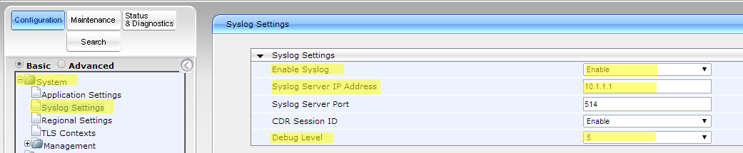
- Activate AC Syslog which gets those syslog messages.

The debug recording (DR) tool can be used to capture media streams, networking and signaling traffic, and other internal board information.
For information on advanced DR options, refer to the User's Manual.

The debug recording (DR) tool can be used to capture media streams, networking and signaling traffic, and other internal board information.
For information on advanced DR options, refer to the User's Manual.
- To make a DR, take the following steps:
- In the URL field, append the suffix ‘FAE’ (note that it’s case-sensitive) to the IP address of the gateway (e.g., http://10.1.229.17/FAE). The screen displayed below is opened. If required, use the usual user name and password (default: Admin, Admin).
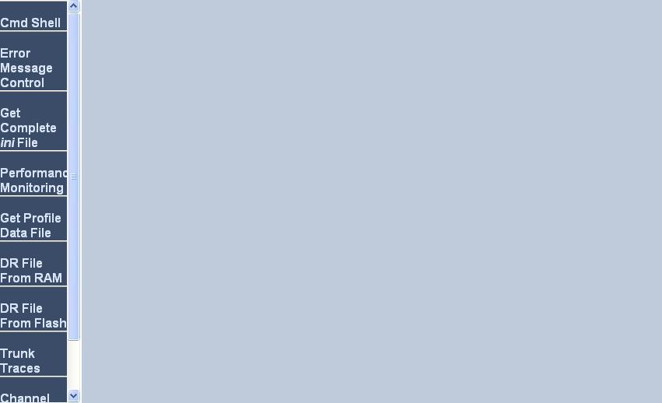

- Press on the link ‘Cmd Shell’; the ‘Cmd Shell’ page (below) is opened in your browser:
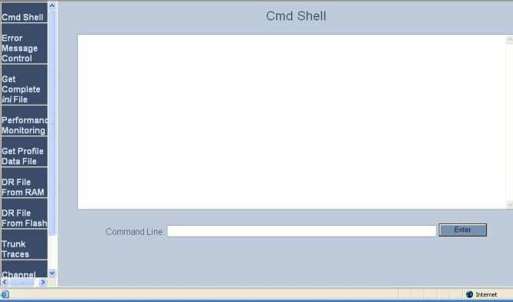

DR
STOP
RTR ALL
RT ALL
AIT <IP of PC running Wireshark> (for example AIT 10.1.1.1)
AIPTT H2N udp a 514
AR
ACIDTR ALL ALL-WITH-PCM 0 10
..
START

Reproduce your problem while recording is running

When finish reproduce issue type ‘STOP’ to stop the recording.

Stop the Wireshark recording and send us the pcap file with call description in order to find the specific call in the pcap recording.

